# BAB IV PENUTUP

## 6.1 Kesimpulan

Berdasarkan hasil analisis dan pembahasan pada Bab V, maka dapat disimpulkan :

1. Didapatkan kondisi ideal luas total fasilitas pelabuhan Kota Bangun sebesar 111,68 m², dengan luas ideal ruang tunggu sebesar 62,49 m² dimana memiliki selisih 40,45 m² dengan kondisi eksisting yang seluas 22,04 m² dengan kebutuhan kursi sebanyak 52 kursi serta luas ideal area kantin sebesar 9,37 m² , area administrasi 9,37 m² , area utilitas 20,30 m² , dan area publik sebesar 10,15 m².
2. Berdasarkan hasil perhitungan analisis *Importance Performance Analysis* didapat nilai rata-rata kepuasan (X) sebesar 2,86 dan nilai rata-rata kepentingan (Y) sebesar 4,67 , terdapat kesenjangan yang signifikan antara kinerja yang dirasakan oleh pengguna jasa dengan harapan mereka. Kesenjangan ini menunjukkan bahwa pengguna jasa merasa bahwa kinerja saat ini jauh dibawah dari yang mereka harapkan, dimana fasilitas yang tidak sesuai dengan Peraturan Menteri Perhubungan No 39 Tahun 2015 tentang Standar Pelayanan Minimum Pelabuhan sebesar 76%. Dan fasilitas yang perlu perbaikan dan peningkatan menurut penilaian penumpang adalah fasilitas yang berada di kuadran 1 seperti ketersediaan kursi di ruang tunggu, kebersihan dan kenyamanan toilet, dan ketersediaan tempat parkir.
3. Pengaturan pola alur lalu lintas kendaraan dan penumpang didalam pelabuhan dilakukan untuk menghindari konflik antara pejalan kaki dengan kendaraan roda dua.
4. Desain fasilitas sesuai dengan Peraturan Menteri Perhubungan Nomor 39 Tahun 2015 tentang Standar Pelayanan Penumpang Angkutan Penyeberangan di Pelabuhan.

## 6.2 Saran

1. Pengelola Pelabuhan Kota Bangun perlu meningkatkan pelayanan berdasarkan ketentuan persyaratan pelayanan yang telah ditetapkan dalam Standar Pelayanan Penumpang Angkutan Penyeberangan di Pelabuhan.
2. Diperlukan pengaturan ulang atau penataan ulang sirkulasi lalu lintas kendaraan dan penumpang dengan menambahkan jalur khusus kendaraan sehingga penumpang dapat merasa nyaman dan aman saat beraktivitas di Pelabuhan sesuai dengan Peraturan Direktur Jenderal Perhubungan Darat Nomor : SK.242/HK.10.DRJD/2010 tentang Pedoman Teknis Manajemen Lalu Lintas Penyeberangan.

# DAFTAR PUSTAKA

Anggraeni, D. W. (2012). Adisucipto Yang Berbasis Ergonomi Dengan Program the Sims 3. 30113.

Aulia, E., Ristriana, A., & Port, F. (2023). Perencanaan Pengembangan Fasilitas Sisi Darat di Pelabuhan Penyeberangan Bahaur Kabupaten Pulang Pisau Development Plan of Land Side Facilities at Crossing Bahaur. 1(Nomor 2), 190–202.

Badan Pusat Statistik Kabupaten Kutai Kartanegara. (2013). Kutai Kartanegara dalam Angka 2023.

Christie, R. E. (2020). Peningkatan Kinerja Fasilitas Pelabuhan Samarinda. Peningkatan Kinerja Fasilitas Pelabuhan ….

Fuad, A. (2021). Analisis Faktor Yang Mempengaruhi Keselamatan Operasional Kapal di Pelabuhan Pada KSOP Bima.

Hartatik, N., & Teknik, F. (2023). Analisis tingkat kepuasan pelayanan penumpang pelabuhan kamal jawa timur 1,2. … Teknik Dan Manajemen …,

18–25.

K, M. R. K. (2019). Pelabuhan Penumpang Ampera Kota Palembang. November.

kukarkab.go.id. (2012). Penyusunan FS Pembangunan Pelabuhan Bongkar Muat Kota Bangun Kabupaten Kutai Kartanegara.

Makasudede, Y. (2018). Strategi Peningkatan Kualitas Pelayanan Pelabuhan Semayang Balikpapan. 8–45.

Nadia Tatyani Habibah, et al. (2020). Rencana pengembangan fasilitas sisi darat pelabuhan penyeberangan teluk bungus kota padang. ITERA (Institut Teknologi Sumatera, 23-24 Oktober, 1–10.

Pedoman Penyelenggaraan Fasilitas Parkir Nomor 272 tahun 1996

Peraturan Direktur Jenderal Perhubungan Darat Nomor: SK. 2681/AP.005/DRJD/2006 . Pengoperasian Pelabuhan Penyeberangan

Peraturan Menteri Perhubungan No 39 Tahun 2015. (2015). Penyelenggaraan angkutan Penyeberangan

Peraturan Menteri Perhubungan Nomor 61 Tahun 2021. (2021) Penyelenggaraan Angkutan Sungai dan Danau

Peraturan Menteri Perhubungan Republik Indonesia Nomor PM 40 Tahun 2022.

(2022). Penyelenggaraan Pelabuhan Sungai dan Danau. 1–8.

Peraturan Pemerintah Nomor 61 Tahun 2009 tentang Kepelabuhan

Pola Umum Praktik Kerja Lapangan Kabupaten Kutai Kartanegara Tahun 2023. Tim PKL Taruna/I Angkatan XLII

Sigurdsson H., H. B. M. S. R. H. y S. J. (2000). Studi Ultilitas Fasilitas Pelabuhan Penyeberangan. Encyclopedia of Volcanoes., 1995, 662.

Triatmodjo. (2019). Kinerja Dan Pelayanan Operasional Pelabuhan Penumpang Tenau. Journal Teknik Sipil, VII(2), 206–218.

Undang – undang Republik Indonesia Nomor 17 tahun 2008. (2008) Pelayaran

# LAMPIRAN

**Lampiran 1** Formulir Kuisioner Tingkat Kepuasan dan Kepentingan

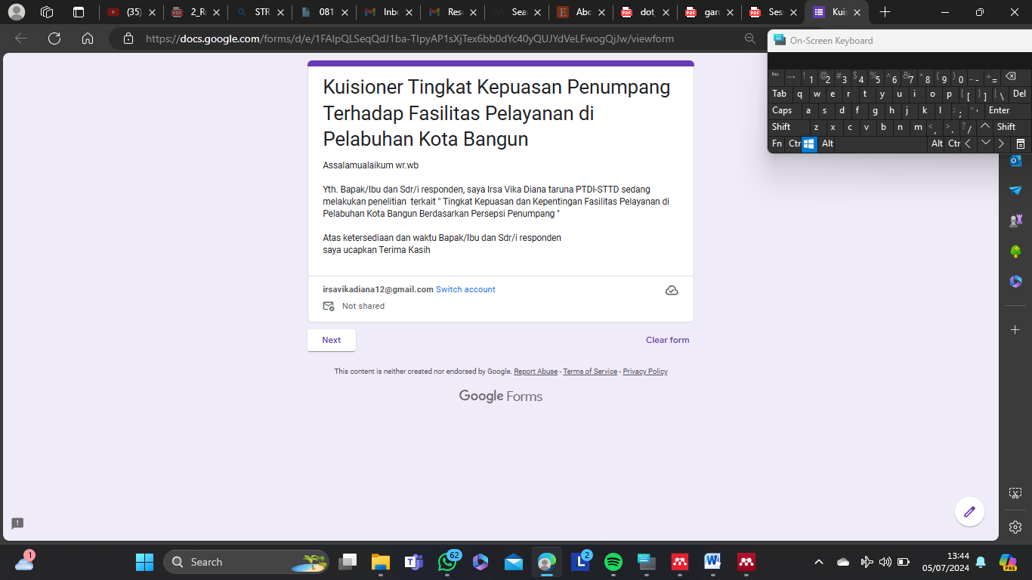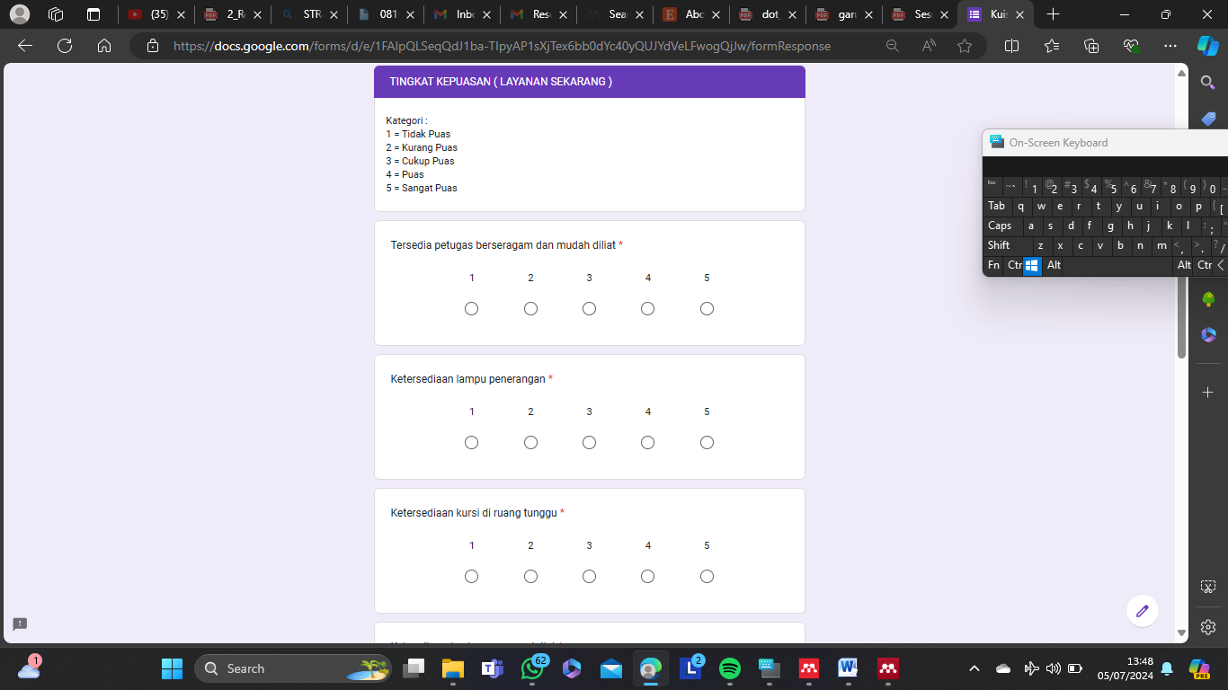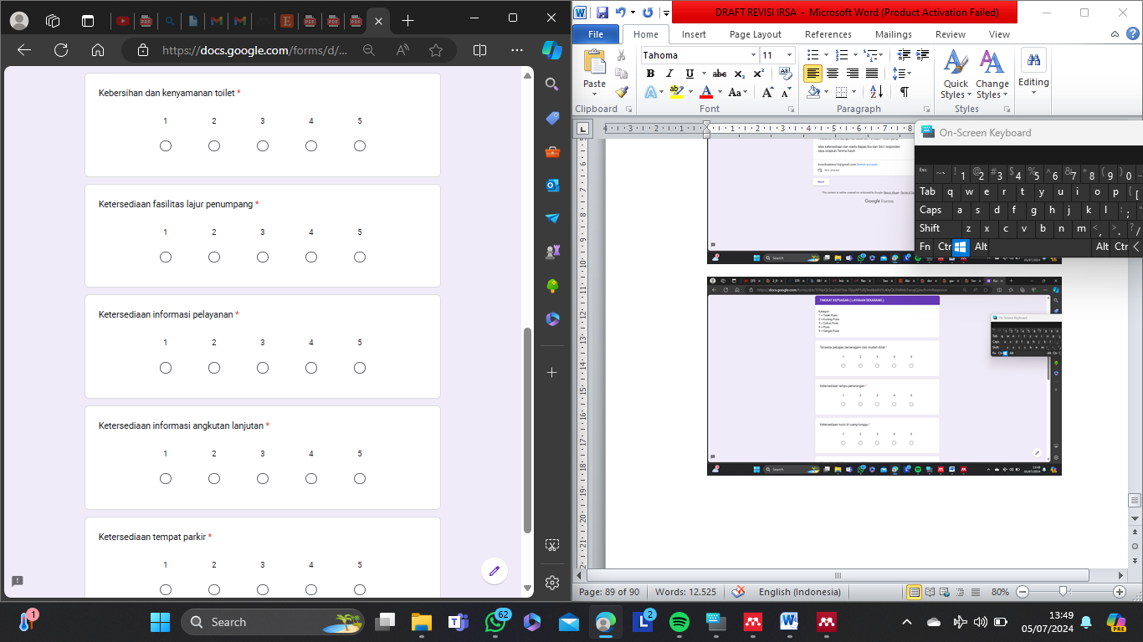

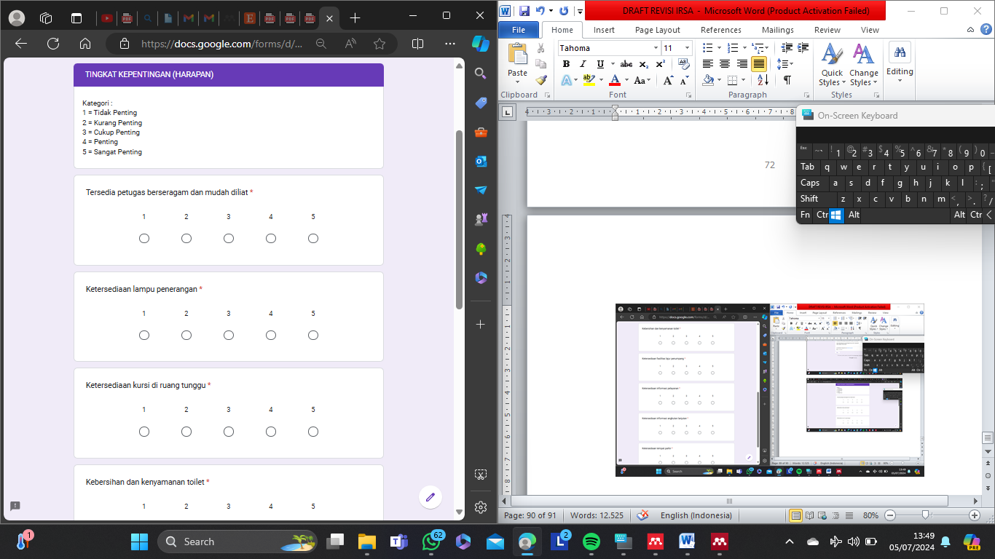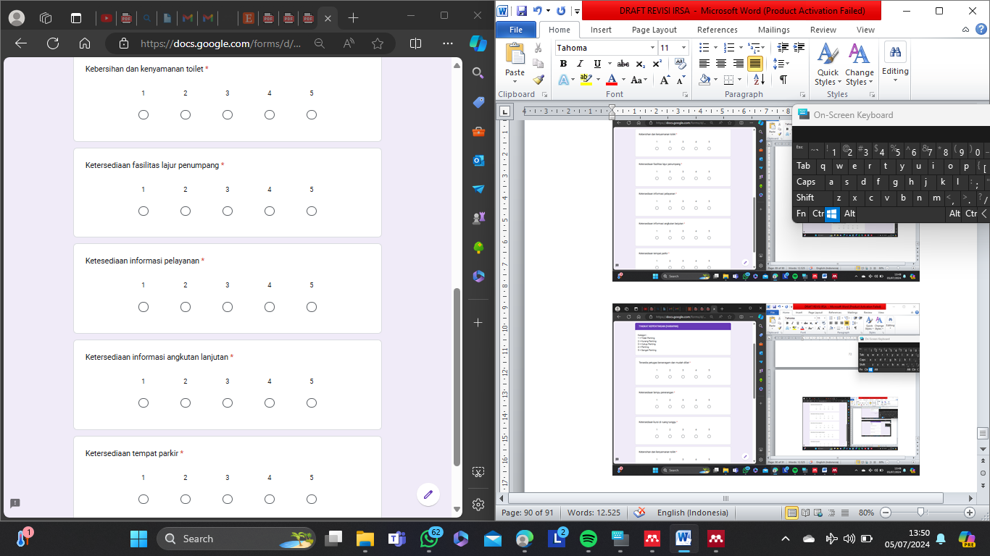

**Lampiran 2** Hasil Survei Tingkat Harapan dan Kinerja

| Responden | Kepentingan | | | | | | | | Kepuasan | | | | | | | |
| --- | --- | --- | --- | --- | --- | --- | --- | --- | --- | --- | --- | --- | --- | --- | --- | --- |
| 1 | 2 | 3 | 4 | 5 | 6 | 7 | 8 |  |  |  |  |  |  |  |  |
| 1 | 2 | 3 | 4 | 5 | 6 | 7 | 8 |
| 1 | 5 | 5 | 5 | 5 | 5 | 4 | 5 | 5 | 4 | 3 | 4 | 3 | 5 | 3 | 3 | 1 |
| 2 | 4 | 4 | 5 | 5 | 5 | 4 | 5 | 5 | 5 | 3 | 3 | 2 | 3 | 3 | 3 | 1 |
| 3 | 5 | 5 | 5 | 5 | 5 | 4 | 5 | 5 | 4 | 4 | 3 | 2 | 2 | 3 | 3 | 1 |
| 4 | 4 | 4 | 5 | 4 | 4 | 4 | 4 | 5 | 4 | 4 | 3 | 3 | 3 | 4 | 3 | 3 |
| 5 | 5 | 5 | 5 | 5 | 5 | 4 | 5 | 5 | 5 | 2 | 4 | 3 | 4 | 3 | 3 | 2 |
| 6 | 5 | 5 | 5 | 5 | 5 | 4 | 5 | 5 | 3 | 3 | 2 | 2 | 2 | 3 | 3 | 2 |
| 7 | 4 | 4 | 5 | 5 | 5 | 4 | 5 | 5 | 5 | 3 | 3 | 2 | 2 | 3 | 3 | 1 |
| 8 | 5 | 5 | 5 | 5 | 5 | 4 | 5 | 5 | 4 | 3 | 3 | 3 | 2 | 3 | 3 | 1 |
| 9 | 4 | 4 | 5 | 5 | 5 | 4 | 5 | 5 | 4 | 4 | 2 | 2 | 4 | 3 | 3 | 2 |
| 10 | 5 | 5 | 5 | 4 | 4 | 4 | 4 | 5 | 4 | 4 | 3 | 2 | 3 | 3 | 3 | 3 |
| 11 | 4 | 4 | 4 | 5 | 5 | 4 | 5 | 5 | 3 | 5 | 3 | 1 | 2 | 3 | 3 | 3 |
| 12 | 5 | 4 | 5 | 5 | 5 | 4 | 5 | 5 | 5 | 5 | 4 | 2 | 3 | 3 | 3 | 2 |
| 13 | 5 | 5 | 5 | 5 | 5 | 4 | 5 | 5 | 3 | 3 | 3 | 2 | 3 | 3 | 3 | 1 |
| 14 | 4 | 4 | 4 | 5 | 5 | 5 | 5 | 5 | 4 | 4 | 2 | 2 | 2 | 2 | 2 | 2 |
| 15 | 4 | 4 | 4 | 5 | 5 | 5 | 5 | 5 | 4 | 4 | 2 | 2 | 4 | 2 | 2 | 3 |
| 16 | 5 | 4 | 5 | 4 | 4 | 4 | 4 | 5 | 5 | 3 | 3 | 3 | 3 | 3 | 2 | 2 |
| 17 | 5 | 5 | 5 | 5 | 5 | 4 | 4 | 4 | 4 | 4 | 2 | 2 | 4 | 2 | 1 | 1 |
| 18 | 4 | 4 | 5 | 5 | 5 | 5 | 5 | 5 | 5 | 3 | 3 | 2 | 3 | 2 | 2 | 2 |
| 19 | 5 | 5 | 5 | 5 | 5 | 4 | 4 | 4 | 4 | 4 | 3 | 2 | 3 | 3 | 2 | 1 |
| 20 | 5 | 4 | 5 | 5 | 5 | 4 | 4 | 4 | 5 | 4 | 2 | 1 | 3 | 2 | 1 | 2 |
| 21 | 4 | 4 | 5 | 5 | 5 | 5 | 5 | 4 | 5 | 3 | 3 | 2 | 2 | 2 | 3 | 2 |
| 22 | 4 | 4 | 5 | 5 | 5 | 5 | 4 | 4 | 4 | 4 | 3 | 2 | 3 | 3 | 1 | 2 |
| 23 | 4 | 4 | 5 | 5 | 5 | 5 | 4 | 4 | 4 | 4 | 3 | 2 | 2 | 3 | 1 | 2 |
| 24 | 5 | 5 | 5 | 5 | 4 | 4 | 4 | 5 | 4 | 4 | 2 | 2 | 3 | 3 | 2 | 2 |
| 25 | 4 | 4 | 4 | 4 | 4 | 4 | 4 | 4 | 4 | 3 | 2 | 2 | 3 | 3 | 1 | 2 |
| 26 | 4 | 4 | 5 | 5 | 4 | 4 | 4 | 5 | 4 | 4 | 2 | 1 | 3 | 4 | 1 | 2 |
| 27 | 4 | 4 | 4 | 4 | 5 | 5 | 4 | 4 | 3 | 3 | 3 | 3 | 2 | 2 | 2 | 1 |
| 28 | 5 | 5 | 5 | 5 | 4 | 4 | 5 | 5 | 4 | 3 | 2 | 1 | 2 | 3 | 2 | 2 |
| 29 | 4 | 4 | 4 | 4 | 4 | 5 | 4 | 4 | 4 | 2 | 3 | 3 | 3 | 3 | 2 | 2 |
| 30 | 5 | 4 | 5 | 5 | 4 | 4 | 4 | 5 | 4 | 4 | 3 | 1 | 2 | 2 | 2 | 2 |
| 31 | 5 | 5 | 5 | 5 | 5 | 5 | 4 | 4 | 3 | 3 | 3 | 2 | 3 | 3 | 2 | 1 |
| 32 | 5 | 5 | 5 | 4 | 4 | 5 | 4 | 4 | 4 | 3 | 2 | 2 | 4 | 3 | 2 | 2 |
| 33 | 4 | 4 | 4 | 4 | 5 | 5 | 4 | 4 | 4 | 2 | 4 | 3 | 4 | 3 | 2 | 2 |
| 34 | 5 | 5 | 5 | 5 | 4 | 5 | 4 | 5 | 4 | 3 | 4 | 2 | 3 | 3 | 2 | 2 |
| 35 | 4 | 4 | 5 | 5 | 4 | 5 | 4 | 5 | 3 | 3 | 3 | 2 | 3 | 2 | 2 | 3 |
| 36 | 5 | 4 | 5 | 5 | 5 | 5 | 4 | 4 | 4 | 3 | 3 | 2 | 3 | 1 | 2 | 2 |
| 37 | 5 | 5 | 5 | 5 | 5 | 5 | 5 | 5 | 4 | 3 | 3 | 3 | 4 | 3 | 2 | 1 |
| 38 | 5 | 5 | 5 | 5 | 5 | 5 | 5 | 5 | 4 | 4 | 4 | 2 | 4 | 3 | 2 | 1 |
| 39 | 5 | 5 | 5 | 5 | 5 | 5 | 5 | 5 | 4 | 4 | 4 | 2 | 3 | 2 | 2 | 2 |
| 40 | 4 | 4 | 4 | 5 | 5 | 5 | 5 | 5 | 4 | 5 | 3 | 3 | 4 | 3 | 2 | 2 |
| 41 | 5 | 5 | 5 | 5 | 5 | 5 | 5 | 5 | 5 | 4 | 3 | 2 | 3 | 3 | 2 | 2 |
| 42 | 5 | 5 | 5 | 5 | 5 | 5 | 5 | 5 | 5 | 3 | 3 | 2 | 4 | 2 | 2 | 1 |
| 43 | 4 | 4 | 4 | 5 | 5 | 5 | 5 | 5 | 4 | 4 | 4 | 3 | 3 | 2 | 2 | 2 |
| 44 | 5 | 5 | 4 | 5 | 5 | 5 | 5 | 5 | 4 | 4 | 4 | 1 | 4 | 2 | 2 | 1 |
| 45 | 5 | 5 | 5 | 5 | 5 | 5 | 5 | 4 | 4 | 3 | 2 | 3 | 4 | 2 | 2 | 1 |
| 46 | 4 | 4 | 5 | 5 | 5 | 5 | 5 | 4 | 5 | 3 | 3 | 2 | 3 | 3 | 2 | 1 |
| 47 | 5 | 5 | 5 | 5 | 5 | 5 | 5 | 5 | 4 | 4 | 5 | 3 | 3 | 3 | 2 | 2 |
| 48 | 5 | 5 | 5 | 5 | 5 | 5 | 5 | 5 | 5 | 3 | 2 | 1 | 4 | 3 | 2 | 1 |
| 49 | 5 | 5 | 5 | 5 | 5 | 5 | 5 | 5 | 4 | 3 | 3 | 2 | 3 | 3 | 2 | 2 |
| 50 | 5 | 5 | 5 | 5 | 5 | 5 | 5 | 5 | 5 | 4 | 2 | 2 | 3 | 1 | 2 | 1 |
| 51 | 5 | 4 | 4 | 4 | 4 | 4 | 4 | 4 | 5 | 4 | 3 | 2 | 2 | 2 | 1 | 2 |
| 52 | 5 | 4 | 5 | 4 | 4 | 4 | 4 | 4 | 5 | 4 | 2 | 2 | 3 | 2 | 1 | 2 |
| 53 | 5 | 5 | 5 | 5 | 4 | 4 | 4 | 4 | 5 | 2 | 3 | 3 | 2 | 3 | 1 | 2 |
| 54 | 4 | 4 | 5 | 5 | 5 | 4 | 4 | 5 | 5 | 2 | 2 | 2 | 2 | 3 | 1 | 2 |
| 55 | 5 | 5 | 4 | 5 | 4 | 4 | 4 | 4 | 4 | 3 | 3 | 3 | 3 | 3 | 1 | 2 |
| 56 | 5 | 4 | 4 | 5 | 4 | 4 | 4 | 4 | 5 | 4 | 2 | 3 | 2 | 3 | 2 | 2 |
| 57 | 5 | 5 | 5 | 5 | 4 | 4 | 4 | 4 | 5 | 3 | 3 | 3 | 4 | 2 | 1 | 2 |
| 58 | 4 | 5 | 4 | 5 | 5 | 4 | 5 | 5 | 3 | 3 | 2 | 3 | 3 | 3 | 3 | 1 |
| 59 | 5 | 5 | 5 | 5 | 4 | 4 | 4 | 4 | 5 | 4 | 2 | 2 | 3 | 2 | 1 | 2 |
| 60 | 5 | 4 | 5 | 4 | 4 | 4 | 4 | 4 | 5 | 4 | 2 | 3 | 3 | 3 | 1 | 2 |
| 61 | 4 | 5 | 5 | 5 | 5 | 4 | 4 | 5 | 5 | 4 | 3 | 2 | 3 | 3 | 3 | 2 |
| 62 | 4 | 4 | 5 | 5 | 4 | 4 | 4 | 5 | 4 | 3 | 3 | 2 | 4 | 2 | 3 | 3 |
| 63 | 4 | 4 | 5 | 5 | 5 | 4 | 4 | 5 | 4 | 3 | 4 | 3 | 3 | 3 | 2 | 3 |
| 64 | 5 | 5 | 5 | 5 | 5 | 5 | 5 | 5 | 5 | 3 | 2 | 2 | 4 | 2 | 1 | 2 |
| 65 | 5 | 5 | 4 | 4 | 5 | 5 | 5 | 5 | 5 | 4 | 2 | 3 | 2 | 2 | 3 | 2 |
| 66 | 5 | 5 | 5 | 5 | 5 | 5 | 5 | 5 | 5 | 4 | 3 | 2 | 3 | 2 | 3 | 2 |
| 67 | 5 | 5 | 5 | 5 | 5 | 5 | 5 | 5 | 5 | 3 | 2 | 2 | 3 | 3 | 1 | 2 |
| 68 | 5 | 5 | 5 | 5 | 5 | 5 | 5 | 5 | 5 | 3 | 3 | 2 | 3 | 2 | 3 | 2 |
| 69 | 5 | 5 | 5 | 5 | 5 | 5 | 5 | 5 | 5 | 4 | 2 | 2 | 3 | 2 | 1 | 2 |
| 70 | 4 | 4 | 4 | 4 | 5 | 5 | 5 | 5 | 5 | 4 | 3 | 2 | 3 | 3 | 2 | 2 |
| 71 | 5 | 5 | 5 | 5 | 5 | 5 | 5 | 5 | 5 | 3 | 2 | 2 | 3 | 3 | 2 | 2 |
| 72 | 5 | 5 | 4 | 5 | 5 | 5 | 5 | 5 | 5 | 4 | 3 | 2 | 4 | 2 | 2 | 2 |
| 73 | 5 | 5 | 5 | 5 | 5 | 5 | 5 | 5 | 5 | 5 | 2 | 2 | 4 | 2 | 1 | 2 |
| 74 | 5 | 5 | 5 | 5 | 5 | 5 | 5 | 5 | 5 | 4 | 3 | 2 | 3 | 2 | 1 | 3 |
| 75 | 4 | 5 | 4 | 5 | 5 | 5 | 5 | 5 | 5 | 3 | 3 | 2 | 5 | 2 | 1 | 2 |
| 76 | 4 | 5 | 5 | 5 | 5 | 5 | 5 | 5 | 5 | 4 | 2 | 2 | 5 | 2 | 2 | 2 |
| 77 | 5 | 5 | 5 | 5 | 5 | 5 | 5 | 5 | 5 | 3 | 3 | 2 | 4 | 3 | 2 | 2 |
| 78 | 4 | 4 | 5 | 5 | 4 | 5 | 4 | 5 | 4 | 4 | 3 | 2 | 4 | 3 | 2 | 1 |
| 79 | 4 | 4 | 5 | 5 | 4 | 5 | 4 | 5 | 4 | 3 | 4 | 2 | 3 | 3 | 2 | 3 |
| 80 | 5 | 5 | 5 | 5 | 4 | 5 | 4 | 5 | 4 | 3 | 4 | 1 | 4 | 2 | 2 | 1 |
| 81 | 4 | 4 | 5 | 5 | 4 | 5 | 4 | 5 | 5 | 4 | 3 | 2 | 4 | 3 | 2 | 1 |
| 82 | 5 | 5 | 5 | 5 | 4 | 5 | 4 | 5 | 4 | 4 | 3 | 1 | 4 | 2 | 2 | 1 |
| 83 | 4 | 4 | 5 | 5 | 5 | 5 | 4 | 5 | 5 | 4 | 2 | 3 | 3 | 3 | 1 | 3 |
| 84 | 5 | 5 | 5 | 5 | 4 | 5 | 4 | 5 | 4 | 3 | 3 | 2 | 3 | 2 | 2 | 1 |
| 85 | 4 | 4 | 4 | 5 | 4 | 5 | 4 | 5 | 5 | 4 | 3 | 2 | 4 | 3 | 1 | 1 |
| 86 | 5 | 5 | 5 | 5 | 5 | 5 | 4 | 5 | 4 | 3 | 3 | 2 | 3 | 2 | 1 | 2 |
| 87 | 4 | 4 | 5 | 5 | 4 | 5 | 4 | 5 | 4 | 3 | 4 | 2 | 3 | 3 | 2 | 2 |
| 88 | 4 | 4 | 5 | 5 | 5 | 5 | 4 | 5 | 5 | 2 | 2 | 1 | 4 | 3 | 1 | 2 |
| 89 | 4 | 5 | 5 | 5 | 4 | 5 | 4 | 5 | 4 | 3 | 3 | 2 | 3 | 3 | 1 | 3 |
| 90 | 4 | 4 | 5 | 5 | 4 | 5 | 4 | 5 | 5 | 2 | 3 | 1 | 4 | 2 | 1 | 1 |
| 91 | 5 | 4 | 4 | 4 | 5 | 4 | 5 | 4 | 5 | 4 | 2 | 3 | 3 | 2 | 2 | 3 |
| 92 | 5 | 5 | 4 | 4 | 5 | 4 | 5 | 5 | 5 | 4 | 2 | 3 | 3 | 3 | 2 | 3 |
| 93 | 4 | 4 | 4 | 4 | 5 | 4 | 5 | 4 | 5 | 3 | 3 | 3 | 4 | 2 | 2 | 2 |
| 94 | 5 | 4 | 5 | 4 | 5 | 4 | 5 | 4 | 5 | 3 | 3 | 3 | 4 | 3 | 2 | 3 |
| 95 | 4 | 4 | 4 | 5 | 5 | 4 | 5 | 4 | 5 | 3 | 3 | 3 | 5 | 3 | 2 | 3 |
| 96 | 5 | 5 | 5 | 4 | 5 | 4 | 5 | 5 | 5 | 3 | 3 | 3 | 5 | 2 | 2 | 3 |
| 97 | 5 | 4 | 4 | 4 | 5 | 4 | 5 | 4 | 5 | 3 | 2 | 3 | 4 | 3 | 2 | 3 |
| 98 | 4 | 4 | 5 | 4 | 5 | 4 | 5 | 4 | 5 | 3 | 3 | 3 | 4 | 2 | 2 | 2 |
| 99 | 5 | 4 | 5 | 4 | 5 | 4 | 5 | 4 | 5 | 3 | 2 | 3 | 3 | 3 | 2 | 3 |
| 100 | 5 | 5 | 5 | 5 | 5 | 4 | 5 | 5 | 4 | 4 | 2 | 3 | 4 | 3 | 2 | 2 |
| 101 | 5 | 4 | 4 | 5 | 5 | 4 | 5 | 4 | 5 | 3 | 3 | 3 | 4 | 2 | 2 | 3 |
| 102 | 5 | 4 | 5 | 5 | 5 | 5 | 5 | 4 | 5 | 3 | 2 | 3 | 2 | 3 | 2 | 2 |
| 103 | 4 | 4 | 5 | 4 | 5 | 4 | 5 | 4 | 5 | 2 | 3 | 3 | 3 | 3 | 2 | 3 |
| 104 | 5 | 5 | 4 | 5 | 5 | 4 | 5 | 4 | 5 | 3 | 2 | 3 | 2 | 2 | 1 | 2 |
| 105 | 5 | 4 | 5 | 4 | 5 | 4 | 5 | 5 | 5 | 3 | 3 | 3 | 3 | 3 | 2 | 3 |
| 106 | 4 | 5 | 5 | 5 | 4 | 5 | 4 | 5 | 5 | 3 | 3 | 2 | 4 | 2 | 3 | 2 |
| 107 | 5 | 5 | 5 | 5 | 4 | 5 | 4 | 5 | 4 | 2 | 3 | 2 | 3 | 2 | 2 | 2 |
| 108 | 5 | 5 | 5 | 5 | 5 | 5 | 5 | 5 | 5 | 4 | 3 | 2 | 3 | 3 | 1 | 2 |
| 109 | 4 | 5 | 5 | 5 | 4 | 5 | 4 | 5 | 5 | 3 | 2 | 2 | 3 | 3 | 3 | 2 |
| 110 | 4 | 4 | 5 | 5 | 5 | 5 | 4 | 5 | 5 | 3 | 2 | 2 | 3 | 3 | 3 | 2 |
| 111 | 4 | 4 | 4 | 5 | 5 | 5 | 4 | 5 | 5 | 4 | 3 | 2 | 2 | 3 | 3 | 2 |
| 112 | 5 | 5 | 5 | 5 | 5 | 5 | 4 | 5 | 5 | 4 | 3 | 2 | 4 | 2 | 3 | 2 |
| 113 | 4 | 4 | 5 | 5 | 5 | 5 | 5 | 5 | 5 | 3 | 3 | 2 | 3 | 2 | 3 | 2 |
| 114 | 4 | 4 | 5 | 5 | 5 | 5 | 4 | 5 | 5 | 3 | 3 | 2 | 4 | 2 | 3 | 2 |
| 115 | 5 | 5 | 5 | 5 | 4 | 5 | 4 | 5 | 5 | 4 | 3 | 2 | 4 | 2 | 3 | 2 |
| 116 | 4 | 4 | 5 | 5 | 4 | 5 | 5 | 5 | 5 | 3 | 3 | 2 | 4 | 3 | 3 | 2 |
| 117 | 5 | 5 | 5 | 5 | 5 | 5 | 4 | 5 | 5 | 3 | 3 | 2 | 3 | 3 | 2 | 2 |
| 118 | 4 | 4 | 5 | 5 | 4 | 5 | 4 | 5 | 4 | 4 | 3 | 2 | 3 | 3 | 2 | 2 |
| 119 | 4 | 4 | 4 | 5 | 5 | 5 | 5 | 5 | 5 | 4 | 2 | 2 | 3 | 3 | 3 | 2 |
| 120 | 4 | 4 | 5 | 5 | 4 | 5 | 4 | 5 | 5 | 3 | 2 | 2 | 3 | 2 | 3 | 2 |
| 121 | 5 | 5 | 5 | 5 | 4 | 5 | 4 | 5 | 5 | 3 | 3 | 2 | 3 | 2 | 2 | 2 |
| 122 | 4 | 4 | 4 | 5 | 5 | 5 | 5 | 5 | 4 | 4 | 3 | 2 | 4 | 3 | 1 | 2 |
| 123 | 5 | 5 | 5 | 5 | 4 | 5 | 4 | 4 | 5 | 4 | 3 | 2 | 3 | 2 | 3 | 2 |
| 124 | 5 | 5 | 5 | 5 | 4 | 5 | 4 | 5 | 5 | 2 | 3 | 2 | 3 | 2 | 3 | 2 |
| 125 | 4 | 4 | 5 | 5 | 4 | 5 | 4 | 5 | 4 | 4 | 3 | 2 | 3 | 2 | 2 | 2 |
| 126 | 4 | 4 | 5 | 5 | 4 | 5 | 4 | 5 | 5 | 3 | 3 | 2 | 3 | 2 | 3 | 2 |
| 127 | 5 | 5 | 5 | 5 | 5 | 5 | 5 | 5 | 5 | 4 | 2 | 2 | 3 | 3 | 2 | 2 |
| 128 | 4 | 4 | 5 | 5 | 4 | 5 | 5 | 5 | 5 | 4 | 3 | 2 | 3 | 3 | 1 | 2 |
| 129 | 5 | 5 | 5 | 5 | 5 | 5 | 5 | 5 | 5 | 3 | 3 | 2 | 4 | 3 | 3 | 2 |
| 130 | 5 | 5 | 5 | 5 | 4 | 5 | 4 | 5 | 5 | 4 | 3 | 2 | 3 | 3 | 2 | 2 |
| 131 | 5 | 5 | 5 | 5 | 4 | 5 | 4 | 5 | 5 | 3 | 3 | 2 | 3 | 2 | 3 | 2 |
| 132 | 4 | 4 | 5 | 5 | 4 | 5 | 4 | 5 | 4 | 3 | 3 | 2 | 3 | 2 | 1 | 2 |
| 133 | 5 | 5 | 5 | 5 | 5 | 5 | 5 | 5 | 5 | 3 | 2 | 2 | 3 | 3 | 2 | 2 |
| 134 | 4 | 5 | 5 | 5 | 4 | 5 | 4 | 5 | 4 | 4 | 3 | 2 | 3 | 3 | 2 | 2 |
| 135 | 4 | 4 | 4 | 5 | 4 | 5 | 4 | 5 | 5 | 3 | 3 | 2 | 4 | 3 | 3 | 2 |
| 136 | 5 | 5 | 4 | 5 | 5 | 5 | 5 | 5 | 5 | 4 | 3 | 2 | 3 | 3 | 2 | 3 |
| 137 | 4 | 4 | 5 | 5 | 5 | 5 | 4 | 5 | 4 | 4 | 4 | 3 | 3 | 3 | 3 | 2 |
| 138 | 5 | 5 | 5 | 5 | 4 | 5 | 4 | 5 | 5 | 3 | 2 | 2 | 3 | 2 | 2 | 3 |
| 139 | 4 | 4 | 4 | 5 | 4 | 5 | 4 | 5 | 5 | 4 | 3 | 3 | 3 | 2 | 2 | 2 |
| 140 | 5 | 5 | 5 | 5 | 4 | 5 | 5 | 5 | 5 | 3 | 4 | 2 | 4 | 3 | 2 | 2 |
| 141 | 4 | 4 | 5 | 5 | 4 | 5 | 4 | 5 | 5 | 3 | 3 | 3 | 3 | 3 | 1 | 2 |
| 142 | 5 | 5 | 5 | 5 | 4 | 5 | 4 | 5 | 5 | 2 | 3 | 2 | 3 | 3 | 2 | 3 |
| 143 | 4 | 4 | 5 | 5 | 4 | 5 | 4 | 5 | 5 | 4 | 3 | 2 | 3 | 2 | 2 | 2 |
| 144 | 5 | 5 | 5 | 5 | 5 | 5 | 5 | 5 | 5 | 3 | 3 | 2 | 3 | 3 | 2 | 2 |
| 145 | 4 | 4 | 5 | 5 | 4 | 5 | 4 | 5 | 5 | 3 | 2 | 2 | 3 | 3 | 3 | 2 |
| 146 | 5 | 5 | 5 | 5 | 4 | 5 | 4 | 5 | 5 | 2 | 3 | 2 | 4 | 3 | 2 | 2 |
| 147 | 5 | 4 | 4 | 4 | 5 | 4 | 5 | 4 | 4 | 3 | 3 | 3 | 2 | 3 | 2 | 3 |
| 148 | 5 | 4 | 4 | 5 | 5 | 4 | 5 | 5 | 5 | 3 | 2 | 3 | 2 | 3 | 2 | 3 |
| 149 | 5 | 5 | 4 | 5 | 5 | 4 | 5 | 4 | 4 | 3 | 3 | 3 | 2 | 3 | 1 | 3 |
| 150 | 5 | 4 | 5 | 5 | 5 | 4 | 5 | 5 | 4 | 3 | 2 | 3 | 3 | 3 | 2 | 3 |
| 151 | 5 | 5 | 5 | 5 | 5 | 5 | 5 | 5 | 4 | 5 | 3 | 3 | 2 | 3 | 2 | 3 |
| 152 | 5 | 4 | 5 | 5 | 5 | 4 | 5 | 5 | 4 | 3 | 2 | 3 | 2 | 3 | 2 | 2 |
| 153 | 5 | 5 | 5 | 5 | 5 | 4 | 5 | 4 | 5 | 3 | 3 | 2 | 2 | 3 | 2 | 3 |
| 154 | 5 | 5 | 5 | 5 | 5 | 4 | 5 | 5 | 5 | 3 | 3 | 3 | 2 | 3 | 2 | 3 |
| 155 | 5 | 4 | 4 | 5 | 5 | 4 | 5 | 5 | 5 | 3 | 2 | 3 | 3 | 3 | 1 | 3 |
| 156 | 5 | 4 | 5 | 5 | 5 | 5 | 5 | 5 | 4 | 3 | 2 | 3 | 2 | 3 | 2 | 3 |
| 157 | 5 | 4 | 5 | 5 | 5 | 4 | 5 | 4 | 5 | 4 | 3 | 2 | 4 | 3 | 2 | 2 |
| 158 | 5 | 4 | 4 | 4 | 5 | 5 | 5 | 4 | 5 | 3 | 2 | 3 | 4 | 4 | 2 | 3 |
| 159 | 5 | 5 | 5 | 5 | 5 | 4 | 5 | 4 | 5 | 3 | 3 | 3 | 3 | 3 | 2 | 3 |
| 160 | 5 | 5 | 5 | 5 | 5 | 4 | 5 | 4 | 4 | 3 | 2 | 3 | 4 | 3 | 1 | 3 |
| 161 | 5 | 4 | 4 | 5 | 5 | 4 | 5 | 4 | 5 | 4 | 3 | 3 | 3 | 3 | 2 | 2 |
| 162 | 5 | 5 | 5 | 5 | 5 | 5 | 5 | 5 | 5 | 3 | 2 | 3 | 2 | 3 | 2 | 2 |
| 163 | 5 | 4 | 4 | 5 | 5 | 4 | 5 | 5 | 4 | 3 | 2 | 3 | 2 | 4 | 2 | 3 |
| 164 | 5 | 5 | 5 | 5 | 5 | 5 | 5 | 4 | 4 | 3 | 4 | 3 | 3 | 3 | 2 | 3 |
| 165 | 4 | 4 | 5 | 5 | 5 | 5 | 4 | 5 | 4 | 3 | 3 | 3 | 3 | 3 | 3 | 3 |
| 166 | 4 | 5 | 5 | 5 | 5 | 5 | 5 | 5 | 5 | 3 | 3 | 2 | 3 | 3 | 3 | 2 |
| 167 | 5 | 5 | 5 | 5 | 5 | 5 | 5 | 5 | 5 | 3 | 2 | 2 | 3 | 3 | 2 | 2 |
| 168 | 5 | 4 | 4 | 4 | 4 | 4 | 4 | 4 | 4 | 4 | 3 | 3 | 4 | 4 | 3 | 1 |
| 169 | 5 | 5 | 5 | 5 | 5 | 5 | 5 | 5 | 4 | 4 | 3 | 3 | 4 | 3 | 3 | 3 |
| 170 | 5 | 5 | 5 | 5 | 5 | 5 | 5 | 5 | 4 | 3 | 3 | 3 | 3 | 3 | 2 | 2 |
| 171 | 4 | 5 | 4 | 4 | 4 | 4 | 4 | 4 | 5 | 3 | 3 | 2 | 3 | 3 | 2 | 2 |
| 172 | 5 | 4 | 5 | 5 | 5 | 4 | 5 | 5 | 4 | 3 | 2 | 2 | 3 | 4 | 1 | 1 |
| 173 | 5 | 4 | 4 | 4 | 5 | 5 | 5 | 5 | 5 | 3 | 2 | 2 | 2 | 3 | 2 | 3 |
| 174 | 5 | 4 | 5 | 4 | 5 | 5 | 5 | 5 | 5 | 3 | 3 | 3 | 2 | 3 | 2 | 1 |
| 175 | 5 | 5 | 4 | 5 | 5 | 4 | 5 | 5 | 4 | 3 | 2 | 3 | 2 | 3 | 2 | 3 |
| 176 | 5 | 4 | 4 | 5 | 5 | 5 | 5 | 5 | 5 | 3 | 2 | 3 | 3 | 4 | 2 | 2 |
| 177 | 5 | 5 | 5 | 5 | 5 | 5 | 5 | 4 | 5 | 4 | 3 | 3 | 2 | 3 | 2 | 1 |
| 178 | 5 | 4 | 5 | 5 | 5 | 5 | 5 | 5 | 5 | 3 | 2 | 3 | 3 | 3 | 2 | 1 |
|  | 824 | 802 | 846 | 861 | 831 | 824 | 813 | 843 | 811 | 596 | 493 | 410 | 558 | 480 | 363 | 367 |
|  | 4,63 | 4,51 | 4,75 | 4,84 | 4,67 | 4,63 | 4,57 | 4,74 | 4,56 | 3,35 | 2,77 | 2,30 | 3,13 | 2,70 | 2,04 | 2,06 |

**Lampiran 3** Survei Parkir

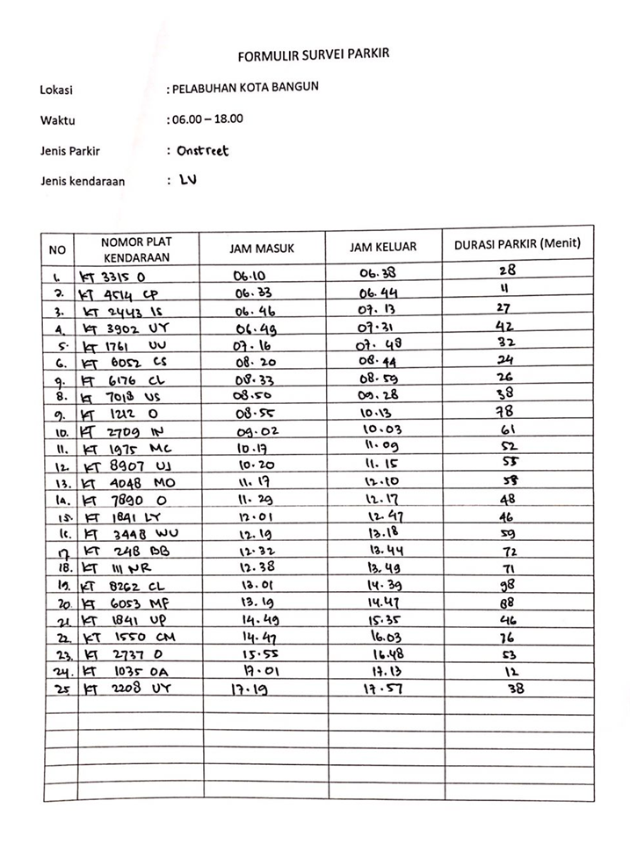

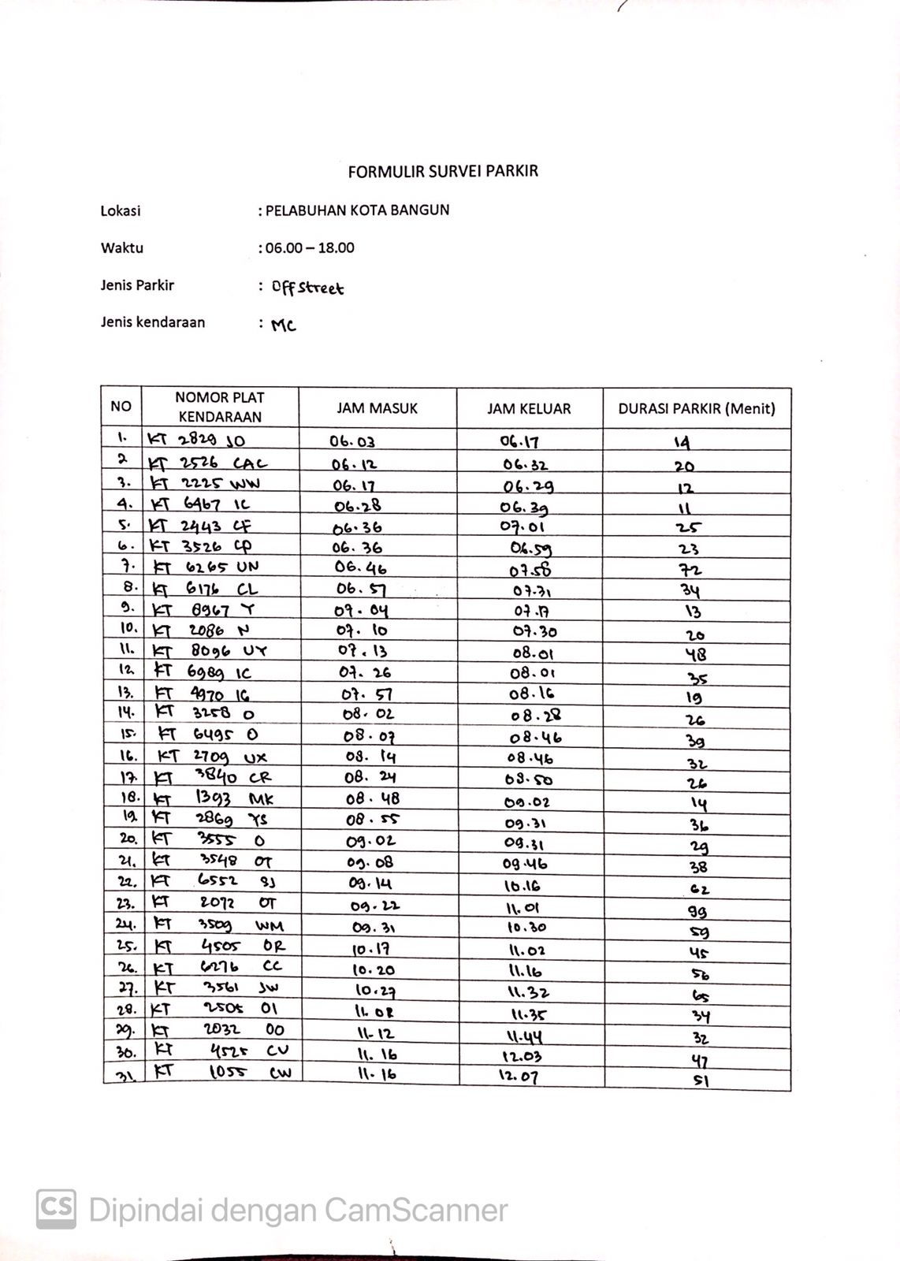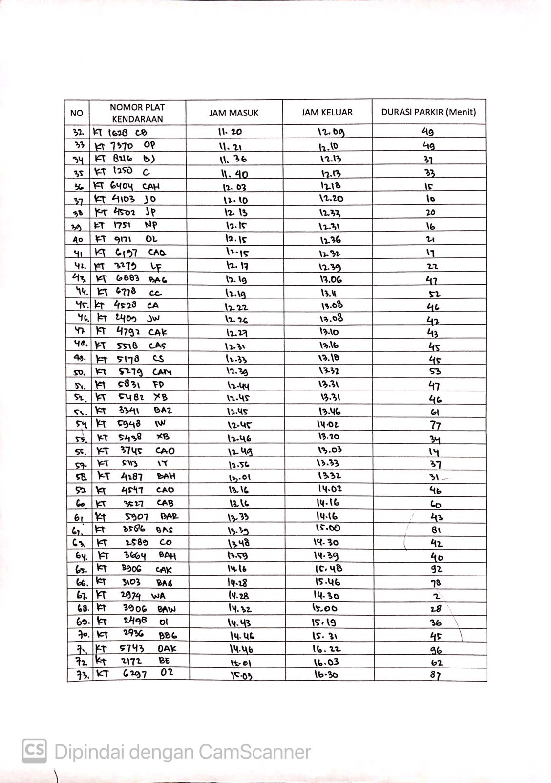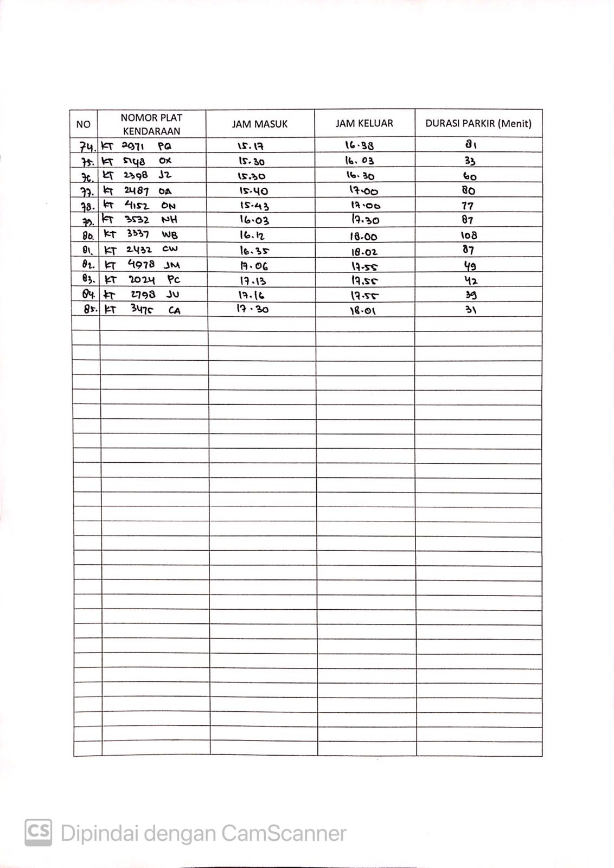

**Lampiran 4** Rekapan Hasil Survei Parkir

|  |  |  |  |  |  |  |  |  |
| --- | --- | --- | --- | --- | --- | --- | --- | --- |
| **Waktu** | **MC** | | | | **LV** | | | |
| **Masuk** | **Keluar** | **Akumulasi** | **Volume** | **Masuk** | **Keluar** | **Akumulasi** | **Volume** |
|  |  |  | 3 | 0 |  |  | 1 | 1 |
| 06.00 - 06.15 | 2 | 0 | 5 | 2 | 1 | 0 | 2 | 2 |
| 06.15 - 06.30 | 2 | 2 | 5 | 4 | 0 | 0 | 2 | 2 |
| 06.30 - 06.45 | 2 | 2 | 5 | 6 | 1 | 2 | 1 | 3 |
| 06.45 - 07.00 | 2 | 1 | 6 | 8 | 2 | 0 | 3 | 5 |
| 07.00 - 07.15 | 3 | 1 | 8 | 11 | 0 | 1 | 2 | 5 |
| 07.15 - 07.30 | 1 | 2 | 7 | 12 | 1 | 0 | 3 | 6 |
| 07.30 - 07.45 | 0 | 1 | 6 | 12 | 0 | 1 | 2 | 6 |
| 07.45 - 08.00 | 1 | 0 | 7 | 13 | 0 | 1 | 1 | 6 |
| 08.00 - 08.15 | 3 | 2 | 8 | 16 | 0 | 0 | 1 | 6 |
| 08.15 - 08.30 | 1 | 2 | 7 | 17 | 1 | 0 | 2 | 7 |
| 08.30 - 08.45 | 0 | 0 | 7 | 17 | 1 | 1 | 2 | 8 |
| 08.45 - 9.00 | 2 | 3 | 6 | 19 | 2 | 1 | 3 | 10 |
| 09.00 - 09.15 | 3 | 1 | 8 | 22 | 1 | 0 | 4 | 11 |
| 09.15 - 09.30 | 1 | 0 | 9 | 23 | 0 | 1 | 3 | 11 |
| 09.30 - 09.45 | 1 | 2 | 8 | 24 | 0 | 0 | 3 | 11 |
| 09.45 - 10.00 | 0 | 1 | 7 | 24 | 0 | 0 | 3 | 11 |
| 10.00 - 10.15 | 0 | 0 | 7 | 24 | 0 | 2 | 1 | 11 |
| 10.15 - 10.30 | 3 | 2 | 8 | 27 | 2 | 0 | 3 | 13 |
| 10.30-10.45 | 0 | 0 | 8 | 27 | 0 | 0 | 3 | 13 |
| 10.45 - 11.00 | 0 | 0 | 8 | 27 | 0 | 0 | 3 | 13 |
| 11.00 - 11.15 | 2 | 2 | 8 | 29 | 0 | 2 | 1 | 13 |
| 11.15 - 11.30 | 4 | 1 | 11 | 33 | 2 | 0 | 3 | 15 |
| 11.30 - 11.45 | 2 | 3 | 10 | 35 | 0 | 0 | 3 | 15 |
| 11.45 - 12.00 | 0 | 0 | 10 | 35 | 0 | 0 | 3 | 15 |
| 12.00 - 12.15 | 6 | 6 | 10 | 41 | 1 | 1 | 3 | 16 |
| 12.15 - 12.30 | 6 | 2 | 14 | 47 | 1 | 1 | 3 | 17 |
| 12.30 - 12.45 | 7 | 4 | 17 | 54 | 2 | 0 | 5 | 19 |
| 12.45 - 13.00 | 3 | 0 | 20 | 57 | 0 | 1 | 4 | 19 |
| 13.00 - 13.15 | 1 | 6 | 15 | 58 | 1 | 0 | 5 | 20 |
| 13.15 - 13.30 | 2 | 3 | 14 | 60 | 1 | 1 | 5 | 21 |
| 13.30 - 13.45 | 2 | 5 | 11 | 62 | 0 | 1 | 4 | 21 |
| 13.45 - 14.00 | 2 | 1 | 12 | 64 | 0 | 1 | 3 | 21 |
| 14.00 - 14.15 | 0 | 2 | 10 | 64 | 0 | 0 | 3 | 21 |
| 14.15 - 14.30 | 3 | 4 | 9 | 67 | 0 | 0 | 3 | 21 |
| 14.30 - 14.45 | 2 | 1 | 10 | 69 | 0 | 1 | 2 | 21 |
| 14.45 - 15.00 | 2 | 2 | 10 | 71 | 2 | 1 | 3 | 23 |
| 15.00 - 15.15 | 2 | 0 | 12 | 73 | 0 | 0 | 3 | 23 |
| 15.15 - 15.30 | 1 | 1 | 12 | 74 | 0 | 0 | 3 | 23 |
| 15.30 - 15.45 | 4 | 1 | 15 | 78 | 0 | 1 | 2 | 23 |
| 15.45 - 16.00 | 0 | 2 | 13 | 78 | 1 | 0 | 3 | 24 |
| 16.00 - 16.15 | 2 | 2 | 13 | 80 | 0 | 1 | 2 | 24 |
| 16.15 - 16.30 | 0 | 3 | 10 | 80 | 0 | 0 | 2 | 24 |
| 16.30 - 16.45 | 1 | 1 | 10 | 81 | 0 | 0 | 2 | 24 |
| 16.45 - 17.00 | 0 | 2 | 8 | 81 | 0 | 1 | 1 | 24 |
| 17.00 -17.15 | 2 | 0 | 10 | 83 | 1 | 1 | 1 | 25 |
| 17.15 - 17.30 | 2 | 1 | 11 | 85 | 1 | 0 | 2 | 26 |
| 17.30 - 17.45 | 0 | 0 | 11 | 85 | 0 | 0 | 2 | 26 |
| 17.45 - 18.00 | 0 | 4 | 7 | 85 | 0 | 1 | 1 | 26 |
| **Jumlah** | **85** |  | **20** |  | **25** |  | **5** |  |

**Lampiran 5** Produktivitas Angkutan Sungai Pelabuhan Kota Bangun

Senin, 24 Juni 2024

|  |  |  |  |  |  |  |  |
| --- | --- | --- | --- | --- | --- | --- | --- |
| No | Nama Kapal | Tujuan |  | Penumpang | | Kendaraan | |
| Jam Sandar | Naik | Turun | Naik | Turun |
| 1 | KM. SAMA MAJU 99 B | Samarinda | 06.02 | 2 | 13 | 0 | 2 |
| 2 | KM. Doa Ibu | Kota bangun | 09.20 | 0 | 8 | 0 | 0 |
| 3 | KM.Doa Ibu | Penyinggahan | 10.20 | 13 | 0 | 0 | 0 |
| 4 | KM. Kubarca | Melak | 11.01 | 1 | 4 | 0 | 0 |
| 5 | KM. Berkah Tiga Dara | Samarinda | 12.33 | 6 | 2 | 0 | 0 |
| 6 | KM. Sadewa | Samarinda | 12.50 | 2 | 0 | 0 | 0 |
| 7 | KM. NOR BUDI C2 | melak | 14.20 | 5 | 0 | 3 | 1 |
| 8 | KM. Berkah Abadi | Melak | 15.10 | 2 | 4 | 0 | 0 |

Selasa, 25 Juni 2024

|  |  |  |  |  |  |  |  |
| --- | --- | --- | --- | --- | --- | --- | --- |
| No | Nama Kapal | Tujuan |  | Penumpang | | Kendaraan | |
| Jam Sandar | Naik | Turun | Naik | Turun |
| 1 | KM. AL MUMINUN | Samarinda | 06.00 | 2 | 10 | 0 | 5 |
| 2 | KM. Doa Ibu | Kota bangun | 09.00 | 0 | 10 | 0 | 0 |
| 3 | KM.Doa Ibu | Penyinggahan | 10.15 | 8 | 0 | 0 | 0 |
| 4 | KM. Berkah Tiga Dara | Melak | 11.02 | 2 | 1 | 0 | 0 |
| 5 | KM. Kubarca | Samarinda | 11.40 | 1 | 5 | 0 | 0 |
| 6 | KM. NOR ANNISA | Melak | 12.19 | 11 | 0 | 2 | 0 |
| 7 | KM. Sadewa | Melak | 14.00 | 5 | 0 | 0 | 0 |
| 8 | Perahu ces | Pela | 14.15 | 9 | 0 | 0 | 0 |
| 9 | KM. Berkah Abadi | Samarinda | 15.55 | 2 | 4 | 0 | 0 |

Rabu, 26 Juni 2024

|  |  |  |  |  |  |  |  |
| --- | --- | --- | --- | --- | --- | --- | --- |
| No | Nama Kapal | Tujuan |  | Penumpang | | Kendaraan | |
| Jam Sandar | Naik | Turun | Naik | Turun |
| 1 | KM. PUTRA MAHAKAM INDAH | Samarinda | 06.10 | 0 | 10 | 0 | 1 |
| 2 | KM. Doa Ibu | Kota bangun | 09.12 | 0 | 9 | 3 | 0 |
| 3 | KM.Doa Ibu | Penyinggahan | 10.10 | 11 | 0 | 0 | 0 |
| 4 | KM. Kubarca | Melak | 11.35 | 0 | 8 | 0 | 0 |
| 5 | KM. Berkah Tiga Dara | Samarinda | 12.00 | 2 | 3 | 0 | 0 |
| 6 | KM. KARYA UTAMA 77G | Melak | 13.10 | 10 | 0 | 4 | 0 |
| 7 | KM. Berkah Abadi | Melak | 14.00 | 6 | 0 | 0 | 0 |
| 8 | KM. Sadewa | Samarinda | 15.15 | 2 | 5 | 0 | 0 |

Kamis, 27 Juni 2024

|  |  |  |  |  |  |  |  |
| --- | --- | --- | --- | --- | --- | --- | --- |
| No | Nama Kapal | Tujuan |  | Penumpang | | Kendaraan | |
| Jam Sandar | Naik | Turun | Naik | Turun |
| 1 | KM. Doa Ibu | Kota bangun | 09.30 | 0 | 12 | 0 | 0 |
| 2 | KM.Doa Ibu | Penyinggahan | 10.15 | 6 | 0 | 0 | 0 |
| 3 | KM. Berkah Tiga Dara | Melak | 10.45 | 8 | 1 | 0 | 0 |
| 4 | KM. Kubarca | Samarinda | 12.00 | 0 | 3 | 0 | 0 |
| 5 | KM. SAMA MAJU 99 B | Melak | 13.45 | 8 | 2 | 3 | 0 |
| 6 | KM. Sadewa | Melak | 14.05 | 6 | 0 | 0 | 0 |
| 7 | KM. Berkah Abadi | Samarinda | 15:10 | 1 | 4 | 0 | 0 |

Jumat, 28 Juni 2024

|  |  |  |  |  |  |  |  |
| --- | --- | --- | --- | --- | --- | --- | --- |
| No | Nama Kapal | Tujuan |  | Penumpang | | Kendaraan | |
| Jam Sandar | Naik | Turun | Naik | Turun |
| 1 | KM. PUTRA MAHAKAM INDAH 2 | Samarinda | 06.00 | 0 | 13 | 0 | 3 |
| 2 | KM. Kubarca | Melak | 11.21 | 5 | 0 | 0 | 0 |
| 3 | KM. Berkah Tiga Dara | Samarinda | 12.20 | 1 | 3 | 0 | 0 |
| 4 | KM. BAROKAH 06 | Melak | 13.10 | 8 | 0 | 6 | 0 |
| 5 | KM. PUTRA MAHAKAM INDAH | Melak | 13.24 | 12 | 0 | 3 | 0 |
| 6 | KM. Sadewa | Samarinda | 14.50 | 0 | 2 | 0 | 0 |
| 7 | KM. Berkah Abadi | Melak | 15.15 | 2 | 0 | 0 | 0 |

Sabtu, 29 Juni 2024

|  |  |  |  |  |  |  |  |
| --- | --- | --- | --- | --- | --- | --- | --- |
| No | Nama Kapal | Tujuan |  | Penumpang | | Kendaraan | |
| Jam Sandar | Naik | Turun | Naik | Turun |
| 1 | KM. Doa Ibu | Kota bangun | 09.00 | 0 | 12 | 0 | 0 |
| 2 | Perahu Ces | Pela | 09.15 | 12 | 0 | 0 | 0 |
| 3 | KM.Doa Ibu | Penyinggahan | 10.00 | 15 | 0 | 0 | 0 |
| 4 | KM. Berkah Tiga Dara | Melak | 10.46 | 3 | 2 | 0 | 0 |
| 5 | KM. Kubarca | Samarinda | 12.39 | 0 | 4 | 0 | 0 |
| 6 | KM. Sadewa | Melak | 12. 53 | 4 | 0 | 0 | 0 |
| 7 | Perahu Ces | Pela | 13.21 | `10 | 0 | 0 | 0 |
| 8 | KM. Berkah Abadi | Samarinda | 15.02 | 1 | 2 | 0 | 0 |
| 9 | Perahu Ces | Pela | 16.12 | 7 | 0 | 0 | 0 |
| 10 | Perahu ces | Kota Bangun | 16.34 | 0 | 10 | 0 | 0 |